# Module 4: Database

Assignment 1: Create MySQL DB Instance and Connect MySQL DB instance

Synopsis:

Below are the steps to perform to create RDS instance in AWS

# Task 1: Create MySQL DB Instance

Step 1: Look for RDS through search box on AWS Console

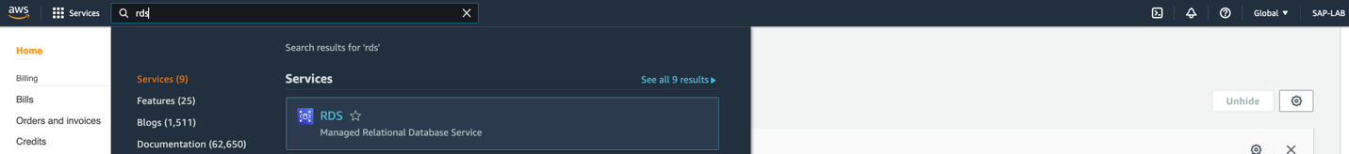

Step 2:Click on create database and configure the properties as suggested below:

1. Creation method – Choose ‘Easy create’
2. Engine type – MySQL
3. MySQL Community edition – MySQL 8.0.15
4. DB instance Size – free tier
5. DB instance identifier – put name for DB
   1. Master username – put Username
   2. Master password – put the password(Which will use for db connection later on)

And click on ‘Create database’.

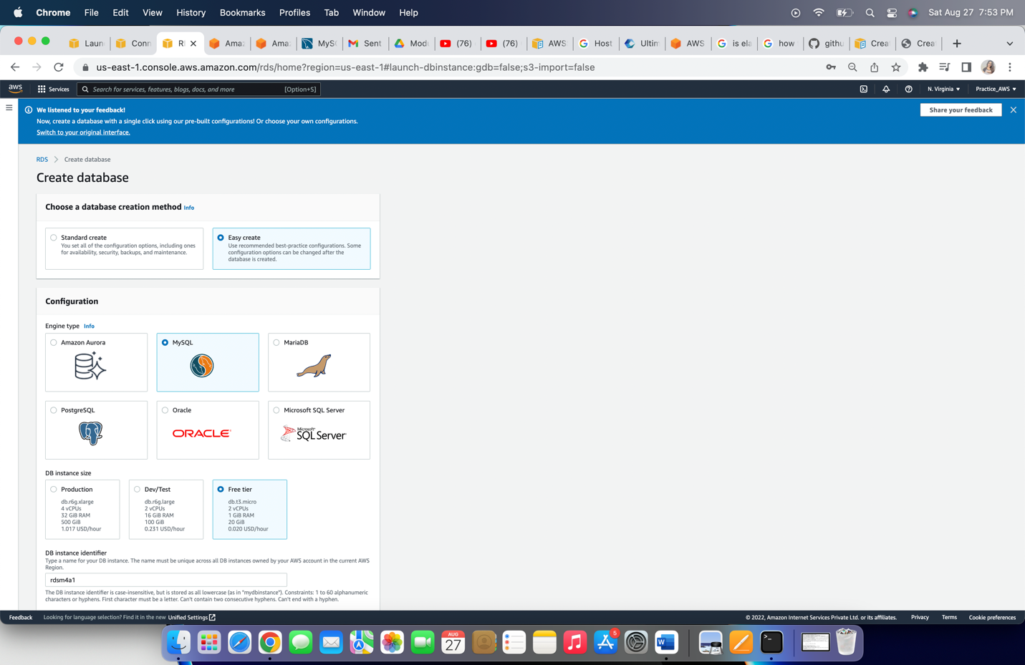

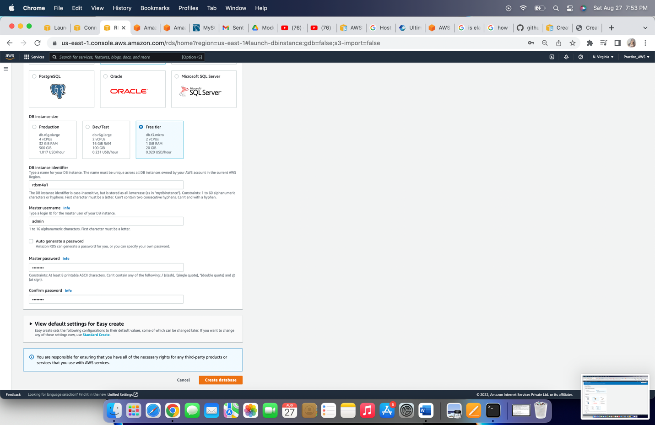

# Task 2: Create EC2 instance

Step 1: Go to EC2 instance dashboard, click on ‘Launch Instance’ and configure below properties:

1. EC2 name – ‘ec2_m4a1’
2. Application and OS Images – Amazon Linux 2 AMI
3. Instance type – t2.micro
4. Key-pair – Create key pair
5. VPC – select the desired VPC or by-default it will select ‘default VPC’
6. Auto-assign public IP – choose ‘Enable’
7. Create Security group

Click on ‘Launch Instance’.

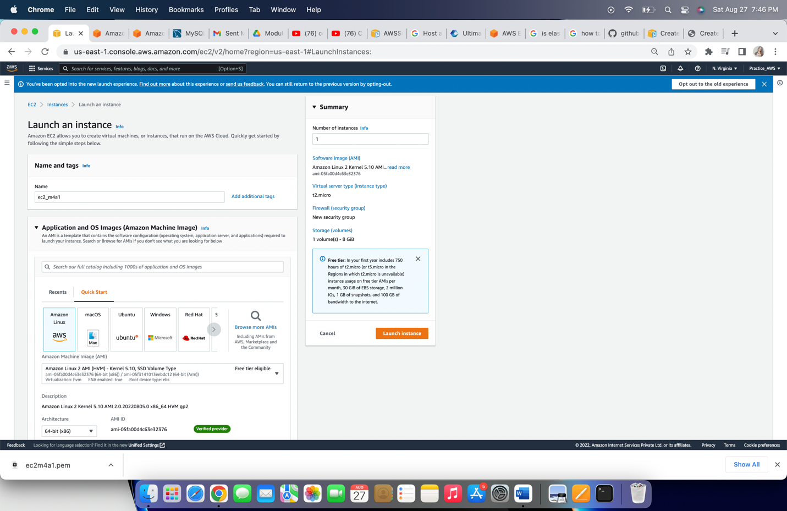

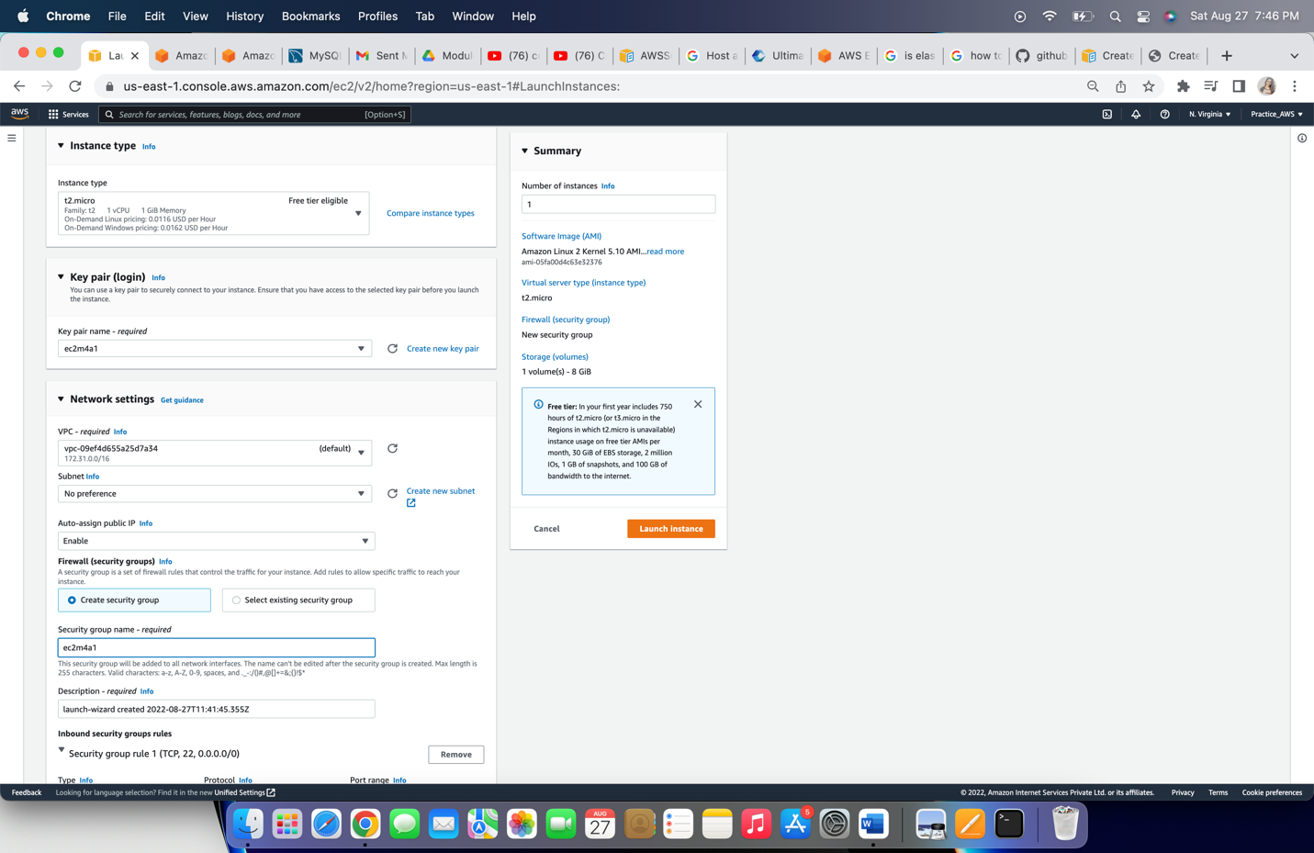

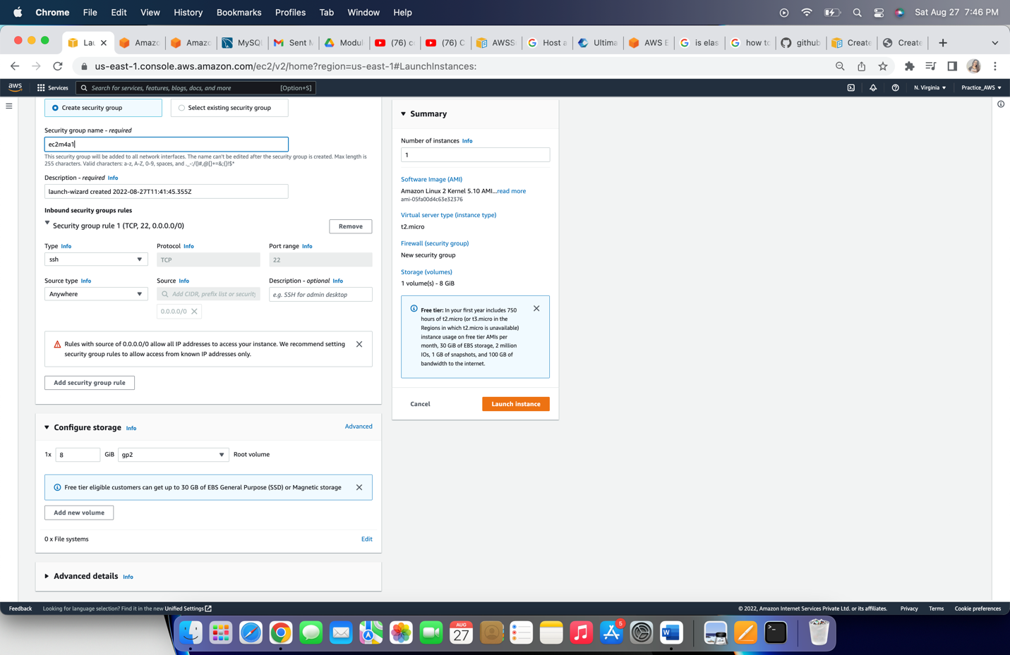

# Task – 3 Connect EC2 and access RDS database

Step 1: Edit the ‘inbound rule’ under security group of RDS.

1. Click on RDS created above, under security click on ‘VPC Security group’.
2. Click on ‘Edit inbound rule’ and access for our ec2 instance pubic IP address.
3. Under type select ‘MySQL/Aurora’ For Protocol and Port it will by-default put ‘TCP’ and ‘3306’. Under Source select ‘Custom’ and then EC2 instance public IP.
4. Click on ‘Save rules’.

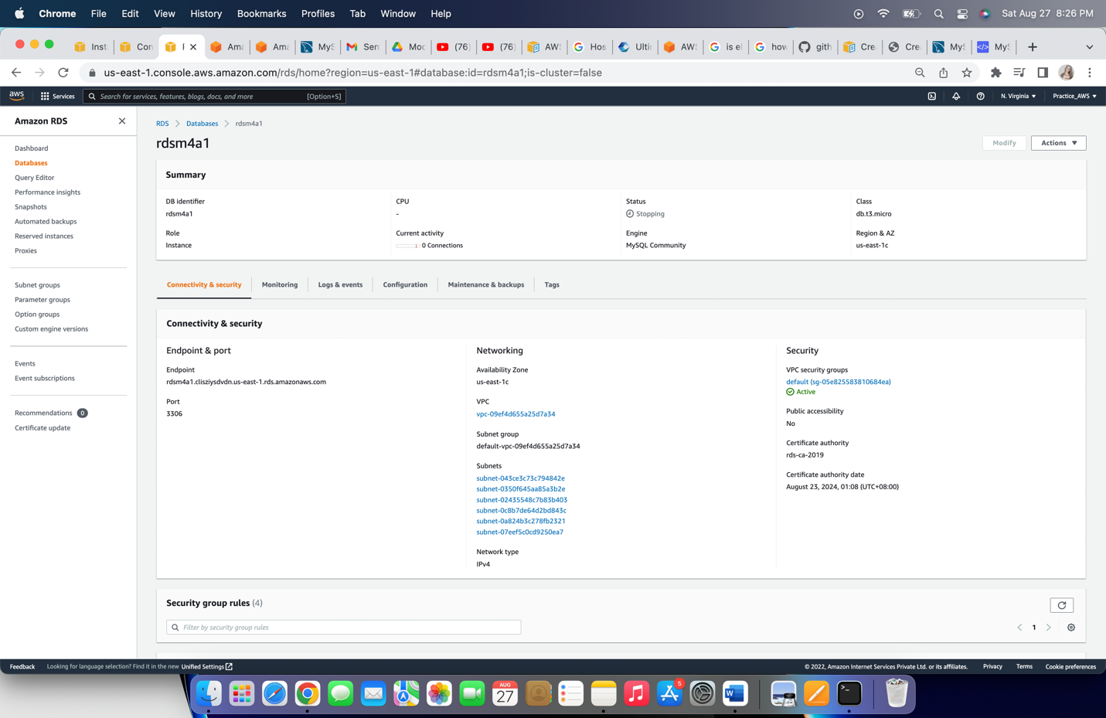

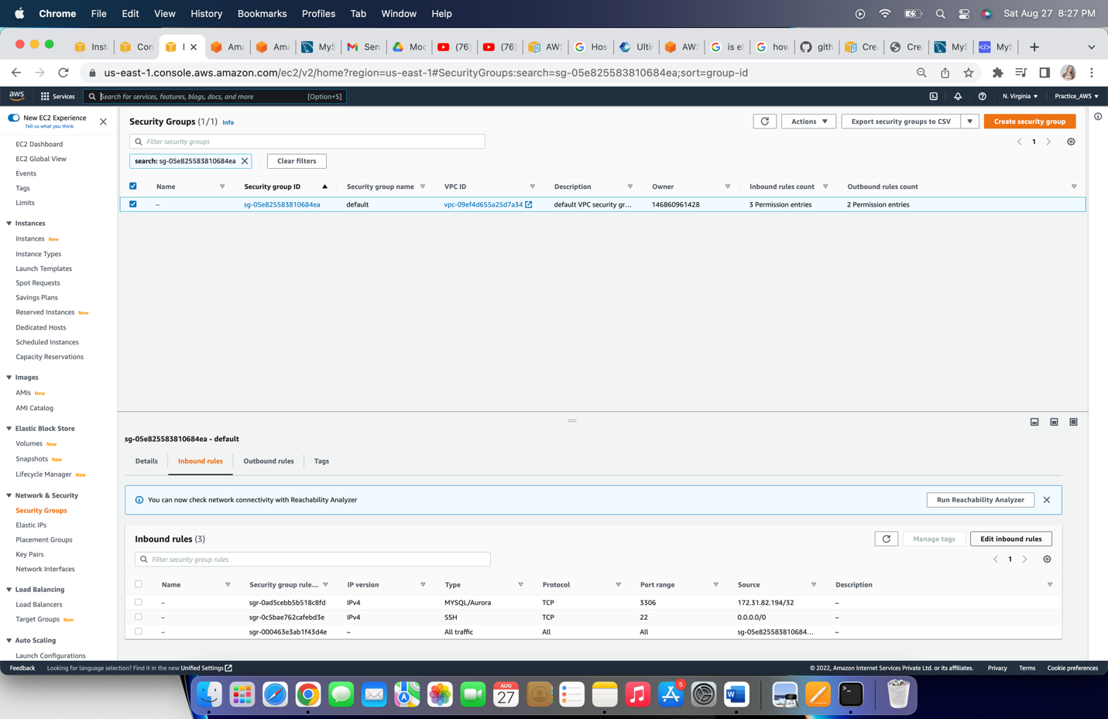

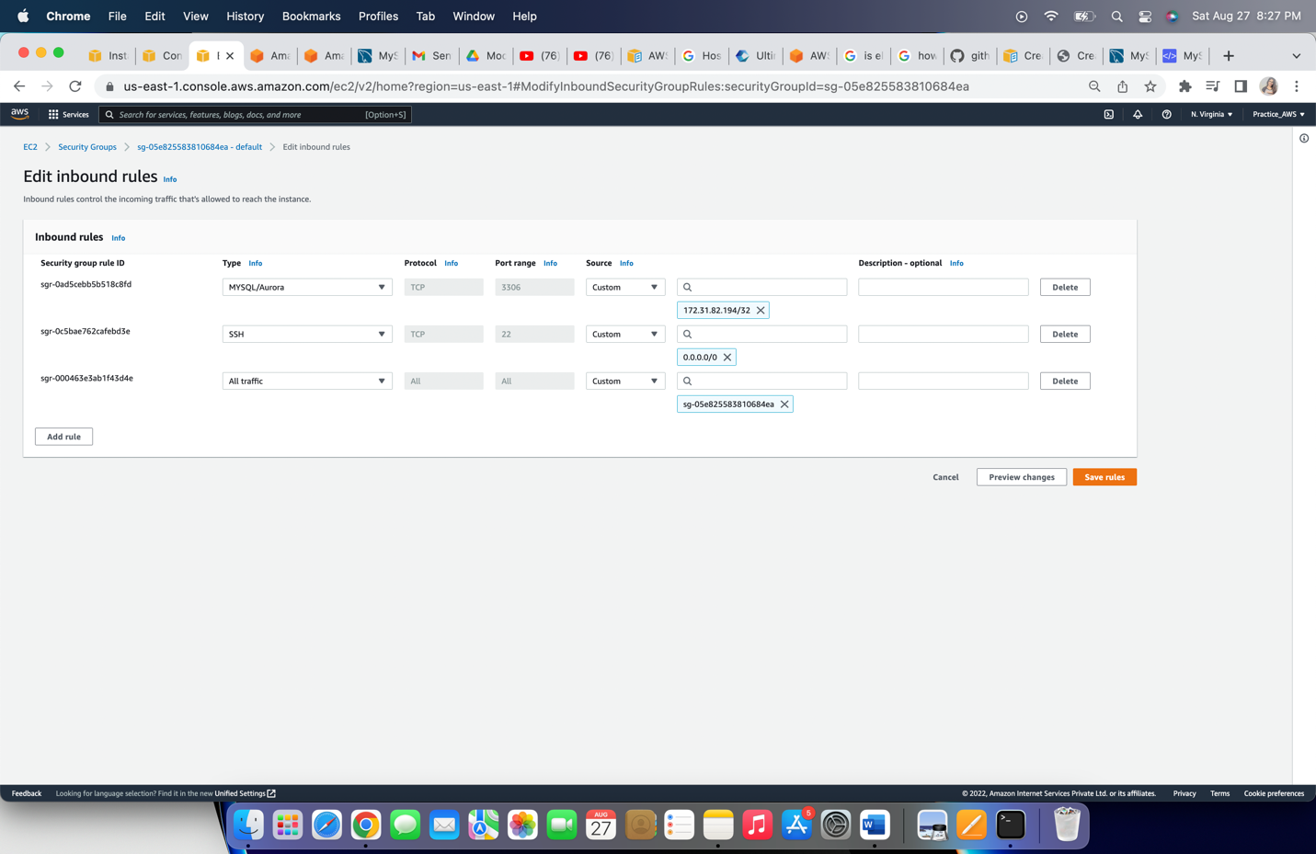

Step 2: Open the terminal on the your machine and execute below commands for actions.

1. Go to the directory, you saved key-pair file,

**cd <directory-name>**

1. Use the chmod command (in bold below) to make sure your private key file isn’t publicly viewable

**chmod 400 <key-pair-filename>**

1. SSH to your EC2 instance

**ssh -i /path_to_key/ec2m4a1.pem ec2-user@public_dns_name**

It will show [ec2-user@ec2-publicIP] on command line

1. To work with mysql, install the mysql on server

**sudo yum install mysql**

it will ask for confirmation with ‘installed size’ of application, put ‘y’ and press enter button. Upon receiving ‘Installed’ and ‘Complete!’ we are ready to proceed.

1. To connect RDS, execute below command

**mysql -h <rds-endpoint> -P 3306 -u admin -p**

it will prompt for password, which we set while creating RDS. Use the password.

We will get ‘Welcome to the MariaDB monitor’ and will be connected to mysql.

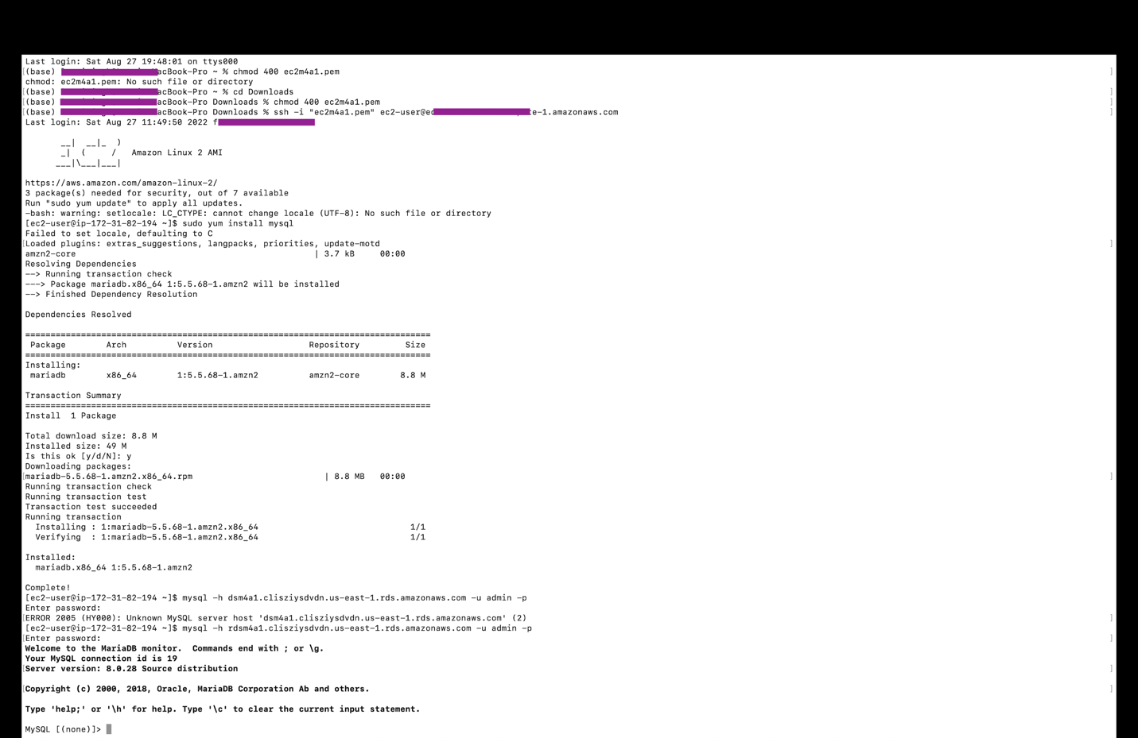

1. To check the available database

**show databases;**

1. To create database

**create database aws_modules;**

1. To use aws_modules

**use aws_modules;**

1. To create table

**CREATE TABLE modules (name VARCHAR(20), owner VARCHAR(20),**

**Status VARCHAR(20), completion DATE);**

1. To check available tables in the database

**Show tables;**

1. To insert data into table

**INSERT INTO modules VALUES (‘M1A1’,’Vaibhav’,’Y’,’2022-07-26’);**

**INSERT INTO modules VALUES ('M4A2’,’Vaibhav’,’N’,NULL);**

1. To read the available data of table

**Select * from modules;**

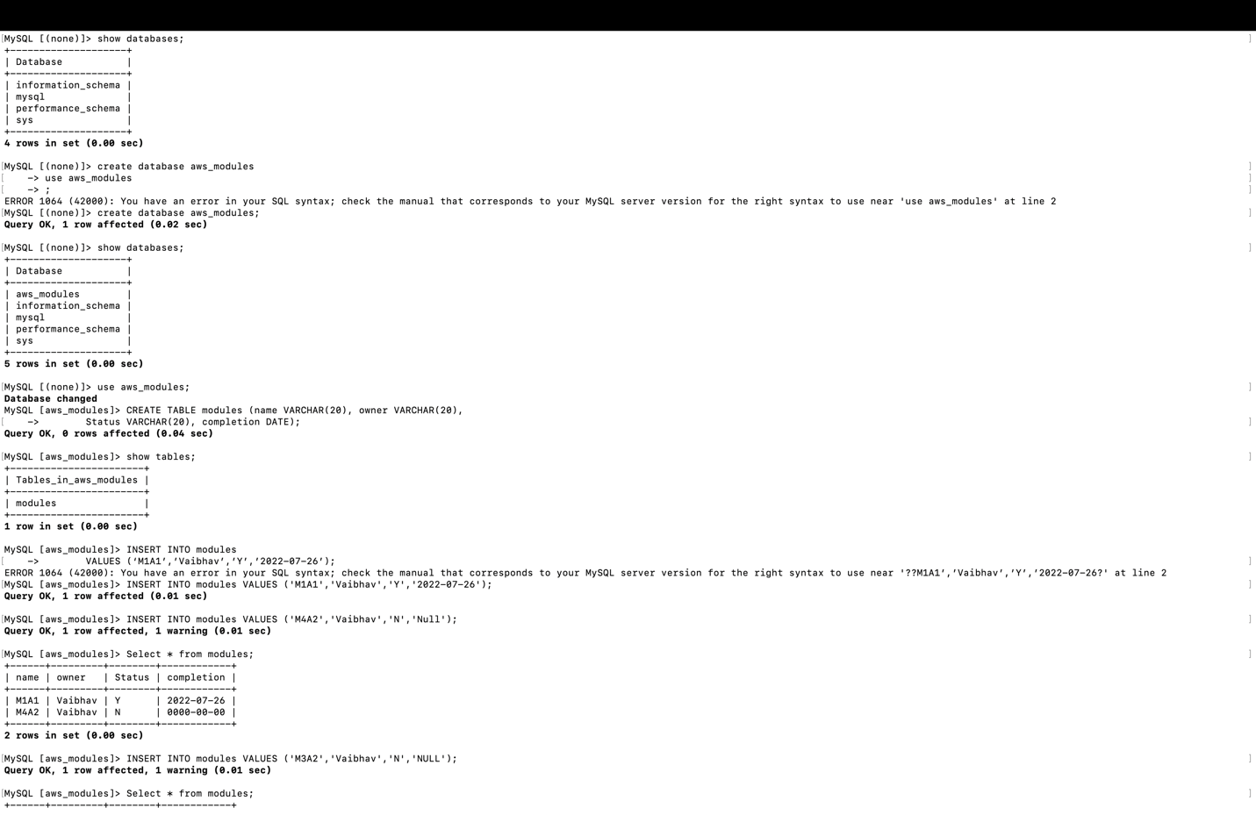

And it will show the available data of table.